Department of Computer Science and Engineering

Assignment Questions

Course Code & Name: CSA0621 –Design and Analysis of Algorithms
Particular | Details
Department: | Computer Science And Engineering
Programme: | B.Tech – AI&DS
Course Code & Course Name | CSA0621 - Design and Analysis of Algorithms
Academic Year / Batch | 2 YEAR / 2024
Faculty Name | Dr G Nagarajan
Assignment Title | Development of an Efficient Algorithmic Solution for Large-Scale Data Processing
Date of Issue | 01-09-2026
Date of Submission | 01-09-2026
Maximum Marks | 100
Course Outcome(s) – CO | CO1: Analyse the efficiency of recursive and non-recursive algorithms using asymptotic notations (Big-O, Ω, Θ) and complexity-analysis methods such as the master theorem, substitution, and iteration.  CO2: Apply brute-force techniques such as sorting and searching to solve computational problems.  CO3: Apply divide-and-conquer techniques to design efficient algorithmic solutions.
Bloom's Taxonomy Level | L4 – Analyse; L5 – Evaluate; L6 – Create
SDG Mapping (SDG 1-17) | SDG 9 – Industry, Innovation and Infrastructure
Industry / Societal Relevance | Smart Infrastructure Planning and Geospatial Data Optimization

Assignment Problem / Challenge
The assignment should preferably require students to:

  - Apply course concepts rather than reproduce theory.
  - Identify and analyze the problem.
  - Consider requirements and constraints.
  - Develop or compare alternative solutions where appropriate.
  - Use relevant modern engineering/computing/design tools.Interpret results.
  - Make and justify engineering decisions.
  - Consider appropriate technical, economic, environmental, societal, ethical, safety or sustainability factors wherever relevant.

Problem Statement
An infrastructure-planning agency maintains a large, publicly available geospatial dataset of facility locations — for example, the OpenFlights airports dataset (~40,000 points) or a cell-tower / weather-station dataset containing 10⁴–10⁶ coordinate records. To detect redundant or dangerously close facilities and to optimise service coverage, the agency must identify the closest pair of locations — the two points separated by the minimum Euclidean distance in the dataset. Develop, implement, and evaluate a solution to this Closest-Pair-of-Points problem. Implement (i) a Brute-Force algorithm that evaluates all n(n−1)/2 pairs, of order O(n²), and (ii) a Divide-and-Conquer algorithm that recursively partitions the point set about the median x-coordinate and merges across the dividing strip, of order O(n log n) ; then develop an optimised hybrid that reverts to brute force below a threshold sub-problem size. Analyse the theoretical efficiency of each approach using Big-O, Ω, and Θ notations, solving the recurrence T(n) = 2T(n/2) + O(n) by the master theorem. Experimentally evaluate all three algorithms on the chosen dataset across increasing input sizes (for example, 10³ to 10⁶ points), measuring execution time, number of distance computations/comparisons, memory utilisation, and scalability. Based on the theoretical and experimental results, optimise the solution and justify why the proposed hybrid is most suitable for large-scale infrastructure data — reflecting Bloom’s Levels 4–6 (Analyse, Evaluate, Create) and contributing to SDG 9 (Industry, Innovation and Infrastructure).

Requirements and Constraints
Use a publicly available real-world coordinate dataset with enough records to test multiple input sizes (10³–10⁶ points). All three algorithms (brute force, divide-and-conquer, hybrid) must be run in the same computational environment for a fair comparison, on identical inputs. Report both empirical timings and operation counts, and clearly document the threshold chosen for the hybrid, along with all assumptions and limitations.

Student Work

Problem Statement and Problem Formulation
The agency has a large dataset containing the locations of facilities such as airports and towers. We need to find the two locations that are closest to each other.
The project focuses on finding the closest pair of locations from a large geospatial dataset. The locations may represent airports, cell towers, weather stations, or other infrastructure facilities. Each location is represented using coordinates, and the objective is to identify the two points having the minimum Euclidean distance. To solve this problem, Brute Force, Divide and Conquer, and Hybrid algorithms are implemented and compared based on their efficiency and performance.
Three methods are used:
- Brute Force
- Divide and Conquer
- Hybrid method

Objective and Expected Outcomes
Objectives
Find the closest two points.
Implement Brute Force.
Implement Divide and Conquer.
Implement Hybrid method.
Compare their performance.
Expected Outcome
The Hybrid and Divide-and-Conquer methods should be faster than Brute Force for large datasets.

Requirements, Constraints and Assumptions
The project requires a geospatial dataset containing coordinate values and a Python programming environment. The program should be able to process different numbers of points and find the minimum distance correctly. The main constraint is that Brute Force performs a large number of comparisons when the dataset is large. It is assumed that the coordinates are valid numerical values and Euclidean distance is used for calculating the distance between two points.
Requirements
Coordinate dataset.
Python program.
Computer to run the program.
Constraints
Large datasets require more processing time.
Brute Force becomes slow for large data.
Assumptions
Each location has X and Y coordinates.
Euclidean distance is used.

Application of Relevant Course Knowledge
This project applies important concepts from algorithm design and analysis. Brute Force is used to check all possible pairs of points, while Divide and Conquer divides the problem into smaller parts. Sorting is used to arrange the points based on their coordinates, and searching is used to find the closest pair. The project also applies recursion, Euclidean distance, Big-O, Big-Ω, Big-Θ, and the Master Theorem.
This project uses:
Sorting
Searching
Brute Force
Divide and Conquer
Euclidean distance
Time complexity
Big-O notation
These concepts are used to find the closest pair efficiently.

Design / Proposed Solution / Methodology
The proposed solution takes the coordinate dataset as input and applies three algorithms to find the closest pair. The Brute-Force algorithm compares every possible pair of points. The Divide-and-Conquer algorithm sorts the points, divides them into two parts, finds the closest pair in each part, and checks the points near the dividing line. The Hybrid algorithm combines both approaches by using Brute Force for small subproblems and Divide and Conquer for larger subproblems.
The proposed system works in three steps:
Read the location coordinates.
Find the closest pair using three algorithms.
Compare their execution time and number of comparisons.
Algorithms Used
Brute Force: Checks every pair.
Divide and Conquer: Divides the points into smaller parts and finds the closest pair.
Hybrid: Uses Divide and Conquer for large parts and Brute Force for small parts.

Pseudocode /Algorithm
Brute Force
Start
Read all points
Set minimum distance
Compare every pair of points
Calculate distance
Store the smallest distance
Display closest pair
Stop
Divide and Conquer
Start
Sort points by X coordinate
Divide points into two parts
Find closest pair in each part
Check points near the middle
Find minimum distance
Display closest pair
Stop
Hybrid
Start
If number of points is small
Use Brute Force
Else
Use Divide and Conquer
Display closest pair
Stop

Source Code and Environment / Tools Used
The project is implemented using Python because it provides simple syntax and is suitable for implementing and testing algorithms. The program can be executed using Google Colab, Jupyter Notebook, or Visual Studio Code. Matplotlib can be used to create graphs for comparing the execution time and performance of the algorithms. A publicly available dataset such as the OpenFlights Airports Dataset can be used for testing.
Programming Language
Python
Tools Used
Python
Google Colab / Jupyter Notebook
Matplotlib
Input
A dataset containing location coordinates.
Output
Closest pair
Minimum distance
Execution time
Number of comparisons

Test Cases and Expected Results
The algorithms are tested using different numbers of points, such as 10, 100, 1,000, 10,000, and larger datasets. The same input data is provided to all three algorithms for fair comparison. All algorithms are expected to produce the same closest pair and minimum distance. The main difference is expected in their execution time and number of comparisons.

Test Case | Points | Expected Result
1 | 10 | Closest pair found
2 | 100 | Correct result
3 | 1,000 | Faster Divide and Conquer
4 | 10,000 | Brute Force becomes slower
5 | 100,000 | Hybrid performs better
All three algorithms should give the same closest distance.

Execution Screenshots
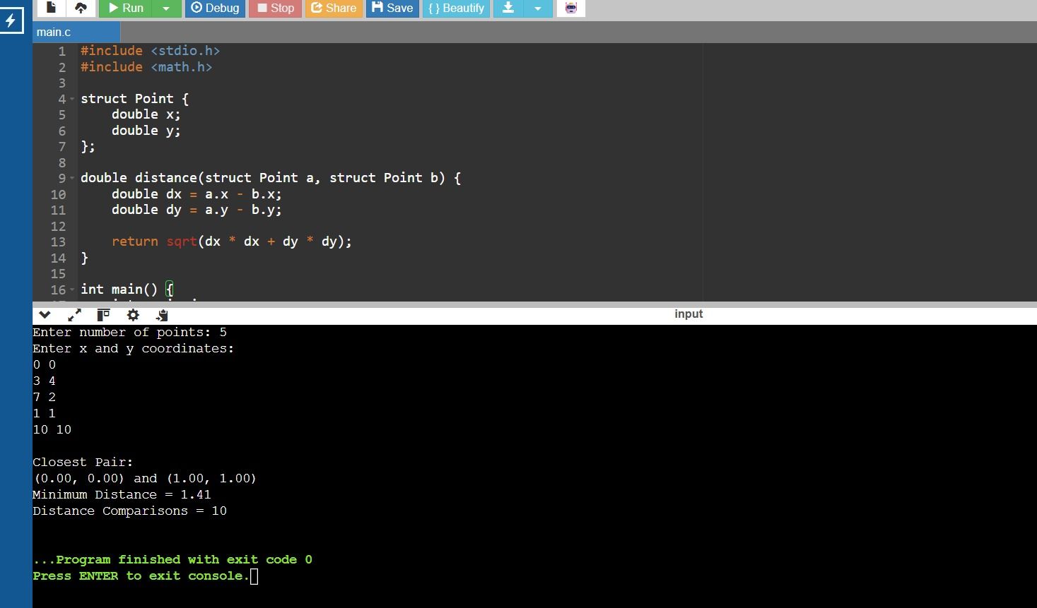

Results and Validation – appropriate tables, graphs, performance metrics, experimental observations, or other evidence, wherever applicable
The results are obtained by running all three algorithms with different input sizes and recording their execution time and number of distance calculations. The Brute-Force method checks every possible pair, so its number of comparisons increases rapidly with the number of points. Divide and Conquer reduces the amount of computation and provides better performance. The Hybrid method also provides efficient results by using Brute Force for smaller subproblems. The results are validated by checking that all three algorithms produce the same minimum distance.
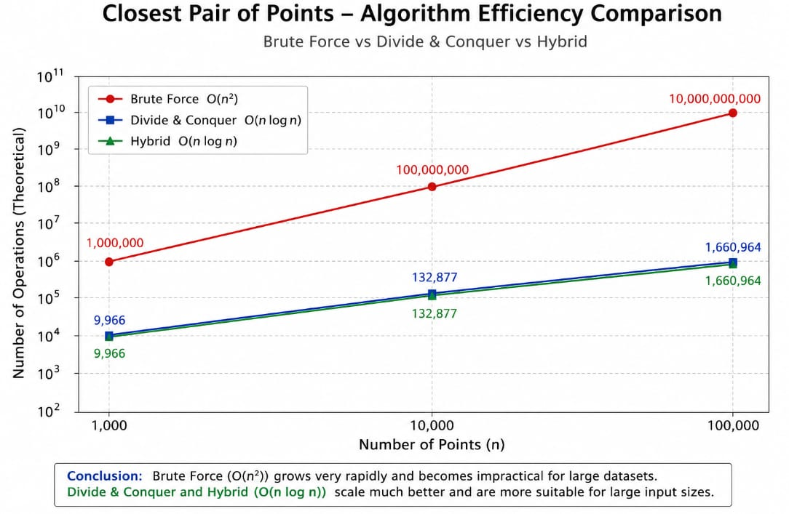

The results show that Divide and Conquer and Hybrid are more suitable for large datasets.

Analysis, Comparison, Trade-offs and Justification of the Final Solution
The Brute-Force algorithm has a time complexity of O(n²), so it is easy to implement but becomes slow for large datasets. The Divide-and-Conquer algorithm has a time complexity of O(n log n), making it more suitable for large datasets. The Hybrid algorithm combines the advantages of both approaches and reduces unnecessary recursive operations for small subproblems. Therefore, the Hybrid algorithm provides a good balance between simplicity, efficiency, and scalability
Algorithm | Time Complexity | Performance
Brute Force | O(n²) | Slow for large data
Divide and Conquer | O(n log n) | Fast
Hybrid | O(n log n) | Fast and efficient

Final Choice
The Hybrid algorithm is selected because it uses the best features of both methods and works efficiently for large datasets.

Broader Considerations / SDG Relevance, wherever applicable
The project can be used in real-world infrastructure planning to identify locations that are very close to each other. It can be useful for airport planning, cell-tower placement, weather-station management, and facility planning. Finding nearby facilities can help reduce redundancy and improve service coverage. The project supports SDG 9 – Industry, Innovation and Infrastructure by applying efficient computational methods to infrastructure-related problems.
This project is related to SDG 9 – Industry, Innovation and Infrastructure.
It can be used for:
Airport planning
Tower planning
Weather station planning
Infrastructure management
It helps organisations make better infrastructure decisions using data.

Conclusion, Limitations and Possible Improvements
Conclusion
The project finds the closest pair of locations using three algorithms. Brute Force is simple but slow for large datasets. Divide and Conquer is faster. The Hybrid method provides a good balance between speed and simplicity.
Limitations
Large datasets require more memory.
Brute Force is slow for very large data.
Euclidean distance may not represent actual geographical distance.
Future Improvements
Use real geographical distance.
Process millions of points faster.

Individual Contribution of Group Members

The project was completed by three group members with responsibilities divided among them. The first member worked on problem formulation, dataset preparation, and Brute-Force implementation. The second member worked on the Divide-and-Conquer algorithm, sorting process, and testing. The third member worked on the Hybrid algorithm, performance analysis, graphs, and documentation. All three members contributed to the final testing, validation, and presentation.
Member | Contribution
Pavana Jana (192472313) | Problem formulation and Brute-Force algorithm
K Harinath Reddy (192572025) | Divide-and-Conquer algorithm and coding
M Vivek Chowdary (192524048) | Hybrid algorithm, testing, graphs and result analysis

References, including datasets, software/tools and other sources used, wherever applicable
• Python Documentation
• OpenFlights Airports Dataset
• Algorithm Design and Analysis concepts
• Brute Force Algorithm
• Divide and Conquer Algorithm
• Big-O Complexity
• SDG 9 – Industry, Innovation and Infrastructure

One-Page Individual Reflection
Individual Reflection – Member 1
This project helped me understand how algorithms can be used to solve real-world problems. Our project was about finding the closest pair of locations from a large dataset. I learned how to understand the problem and find a suitable method to solve it. My main work was understanding the problem, preparing the dataset, and implementing the Brute-Force algorithm. I learned how to represent locations using X and Y coordinates and how to calculate the distance between two points. The Brute-Force method compares every possible pair of points and finds the smallest distance.
While doing this project, I understood that Brute Force is easy to write and understand, but it becomes slow when the number of points increases. I learned about O(n²) time complexity and understood why the number of comparisons increases quickly for large datasets. I also worked with my team members and learned about the Divide-and-Conquer and Hybrid methods. Comparing the three methods helped me understand why choosing the correct algorithm is important. I faced some difficulties while implementing and testing the program, but I solved them by checking the code and discussing the problems with my team members. This improved my programming and problem-solving skills.

Overall, this project was a good learning experience for me. I learned about Brute Force, distance calculation, algorithm complexity, testing, and teamwork. It also increased my confidence in solving programming problems.

Assessment Rubric

Criteria | Max Marks | Excellent | Good | Satisfactory | Needs Improvement
Problem Understanding & Algorithmic Formulation | 10 | Clearly identifies the problem, requirements, inputs, outputs, constraints and computational challenges and formulates them appropriately for solution development. | Problem and major requirements are correctly formulated with minor gaps. | Basic formulation is provided, but requirements or constraints are partially identified. | Problem is poorly understood or inadequately formulated.
Algorithmic Solution Design | 15 | Designs a clear, logical and feasible solution strategy with appropriate algorithmic techniques, pseudocode/flowchart and well-justified design decisions. | Appropriate solution design with minor gaps in logic, representation or justification. | Basic solution design is presented but lacks completeness or clear justification. | Solution design is inappropriate, incomplete or unclear.
Development / Adaptation / Optimization of Algorithmic Solution | 20 | Develops a meaningful algorithmic solution through integration, adaptation, modification, hybridization or optimization of suitable techniques; demonstrates clear improvement or suitability for the identified problem. | Develops an appropriate solution with meaningful adaptation or improvement, with minor limitations. | Solution demonstrates limited adaptation or development beyond standard implementation. | Merely reproduces an existing algorithm with little or no meaningful development or adaptation.
Implementation & Modern Tool Usage | 15 | Developed solution is correctly and efficiently implemented using appropriate programming/computational tools and handles relevant input conditions reliably. | Implementation is functional with minor logical or efficiency issues. | Core implementation works but contains limitations or incomplete functionality. | Implementation is incomplete, unreliable or non-functional.
Efficiency, Testing & Validation | 15 | Performs appropriate complexity evaluation and systematic testing using suitable data/input sizes; validates correctness, efficiency and scalability with clear evidence. | Complexity evaluation and testing are mostly appropriate with minor gaps. | Basic testing and efficiency evaluation are provided but lack sufficient validation. | Testing, complexity evaluation or validation is inadequate or substantially incorrect.
Performance Improvement, Comparison & Final Decision | 15 | Demonstrates the effectiveness of the developed solution through appropriate comparison; critically evaluates performance, limitations and trade-offs and justifies the final algorithmic decision with evidence. | Good performance comparison and justification with minor limitations. | Basic comparison is provided, but improvement or final justification lacks depth. | Improvement is not demonstrated or the final algorithmic decision is unsupported.
Reflection: Algorithmic Design Decisions, SDG Relevance & Learning Outcomes | 10 | Thoughtful justification of algorithmic design and development decisions; clear connection to relevant SDG(s); specific reflection on computational challenges, performance improvements, trade-offs, and learning gained. | Appropriate justification of algorithmic decisions; SDG relevance, challenges, improvements, and learning are discussed but lack depth. | Reflection is present but generic; limited justification of algorithmic decisions, improvements, SDG relevance, or learning outcomes. | No genuine reflection is provided, or the reflection lacks meaningful connection to algorithm development, SDG relevance, challenges, or learning outcomes.

CO–PO–Assessment Mapping

Assessment Component | CO | PO(s) | Bloom's Level | Marks
Problem Understanding & Algorithmic Formulation |  |  | L4 | 10
Algorithmic Solution Design |  |  | L4/L6 | 15
Development / Adaptation / Optimization of Algorithmic Solution |  |  | L5/L6 | 20
Implementation & Modern Tool Usage |  |  | L3/L6 | 15
Efficiency, Testing & Validation |  |  | L4/L5 | 15
Performance Improvement, Comparison & Final Decision |  |  | L4/L5 | 15
Reflection: Algorithmic Design Decisions, SDG Relevance & Learning Outcomes |  |  | L4/L5 | 10
Note: Faculty shall map only the POs and Bloom's levels genuinely assessed by the particular assignment. Every assignment is not required to map to every PO.

Faculty Evaluation & Continuous Improvement CO Attainment

Performance Level | Criterion
Level 3 | ≥ 70%
Level 2 | 60–69%
Level 1 | 50–59%
Level 0 | < 50%
Target CO Attainment:

Actual CO Attainment:

Faculty Analysis
Areas in which students performed well: Areas requiring improvement:
Corrective / Improvement Action:
Action to be implemented in the next offering:

Documents to be Maintained

The department/course faculty shall maintain:

- Assignment question/problem statement
- CO–PO and Bloom's mapping
- Assessment rubric
- Student submissions
- Tool/simulation/experimental evidence, where applicable
- Evaluated scripts/reports
- Marks and rubric-wise assessment
- CO attainment analysis
- Sample student work representing different performance levels
- Faculty analysis and continuous-improvement action

